ok now what we wanted to do next is that

i wanted to
1) use sliding window retraing with window size of 111 days and store the model in way that can be used again for training on extra data in future
2) use TimeSeriesSplit(n_splits=5) and train model to test on val and test both and store the model in way that can be used again for training on extra data in future

for training I will use LSTM with same architecture for both the ways of training

then compare both the results using some metrices like cumulative returns, etc

for each training we extract features from

1) features extracted from prices - return_1d, log_return, lagret_1,2,3,4,5, vol_5/10/20, mom_3/5/10/20, ma_cross_5_20, ma_cross_10_20, price_position, rsi_14, bb_position, mom_flag
2) features extracted from news - use FinBERT for the probabilities of all positive, negative and neutral + confidence score
3) features extracted from momentum - directly use bearish or bullish as binary
Feature Explanations:
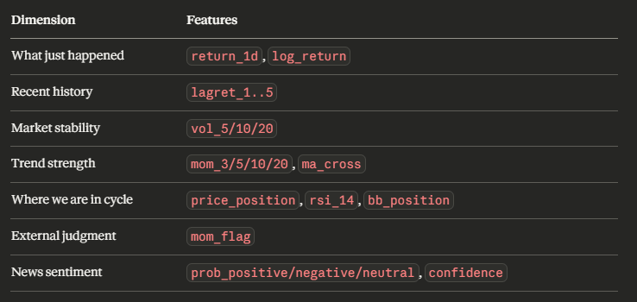

What Happens When New Data Arrives:

This is where your storage decision matters. For both strategies:
1) Sliding window — load the last saved checkpoint, drop the oldest day from the window, add the new day, retrain for a few epochs (not full retraining from scratch). This is fast and keeps the model current.
2) TimeSeriesSplit — load the fold 4 model, append the new rows to the training set, fine-tune for a few epochs. The expanding window naturally accommodates new data.

Both approaches support incremental training (fine-tuning on new data) rather than full retraining — which is important when you eventually deploy this daily.

Evaluation Metrices:
1) Cumulative Return (CR) — total profit over the test period
2) Sharpe Ratio (SR) — return per unit of risk, annualized
3) Maximum Drawdown (MD) — worst peak-to-trough loss
4) Daily and Annual Volatility (DV, AV)

Execution Order

1) Build the full feature pipeline first (price + FinBERT + momentum) and confirm the final feature matrix shape for both BTC and TSLA
2) Run Strategy 2 (TimeSeriesSplit) first — it's simpler to implement and gives you a baseline
3) Run Strategy 1 (Sliding window) second
4) Compare both on the held-out test set (Feb 14 – Mar 24) using all metrics above

Prompt to cursor:
prediction target y is a 3-class classification problem: BUY , SELL or HOLD
(Position mapping: BUY -> long, HOLD -> flat, SELL -> short)

LSTM should be trained like this:
Output layer: Softmax with 3 units (SELL, HOLD, BUY)
Loss function: Sparse categorical cross entropy with class weights (based on class imbalance )

